Endoscopic Reduction of Pouch and Stoma

Roux-en-Y gastric bypass has been performed since the 1960’s, so we have a lot of historical data on patients who have undergone the procedure. Over the past ten years, a lot of research has been focused on outcomes for gastric bypass patients in terms of improvements in safety of the procedure, complications as well as mechanisms of weight regain.

Not all gastric bypass patients regain weight. The patients that struggle with weight regain usually find they are hungry all the time and that their portion size with each meal has increased back to “normal”. Changing the diet to include foods that are low glycemic index foods can help significantly with hunger. This can help lose some of the pounds gained. In many cases, the real problem is the loss of restriction, meaning that the patient can eat larger portions at one sitting. This counteracts the effects of the bypass since initially, patients were eating very little. The loss of the restriction occurs because the hookup of the stomach to the intestine or the gastrojejunostomy can widen or enlarge over time. The gastrojejunostomy can also be referred to as the stoma in gastric bypass patients. So when a patient eats, the food shoots straight out of the pouch and into the intestine. If the food empties out of the pouch quickly, then the portion sizes become bigger.

I have tried a couple of different endoscopic or through the mouth procedures to make the pouch and the stoma smaller. Those procedures were effective in the short term but the method to pull the tissue together wasn’t durable over the longterm. The current method that I am using, an endoscopic suturing device, uses the same type of suture and needle attached to an endoscope, that I use when I operate. The sutures placed using this method are durable and have been evaluated over a year out in some patients. This technique is an exciting, less invasive method without surgical cutting, to reduce the size of the stoma and the pouch. The risk of complications are low with this endoscopic reduction of pouch and stoma.

As with all procedures, the patients are placed on a special diet of 10 days of liquids and 10 days of puree after the procedure. Patients do have to commit to dietary change past the postoperative period. Healthy eating with minimal snacking is the key to long-term success. Exercise is also an integral component to weight maintenance for everyone!. The weight loss has been very good so far, and the patients note a big change in their portion size. Since this is a newer procedure, long-term (>1-2 year) data is not available.

The procedure takes under an hour. Patients need to go under general anesthesia for the procedure. My office will try to submit this to the patient’s insurance company for payment. We have had some success in getting this approved.
Please call the office for an appointment to discuss the risks and benefits of this exciting procedure to combat weight regain.

Image of stoma right after the gastrojejunostomy
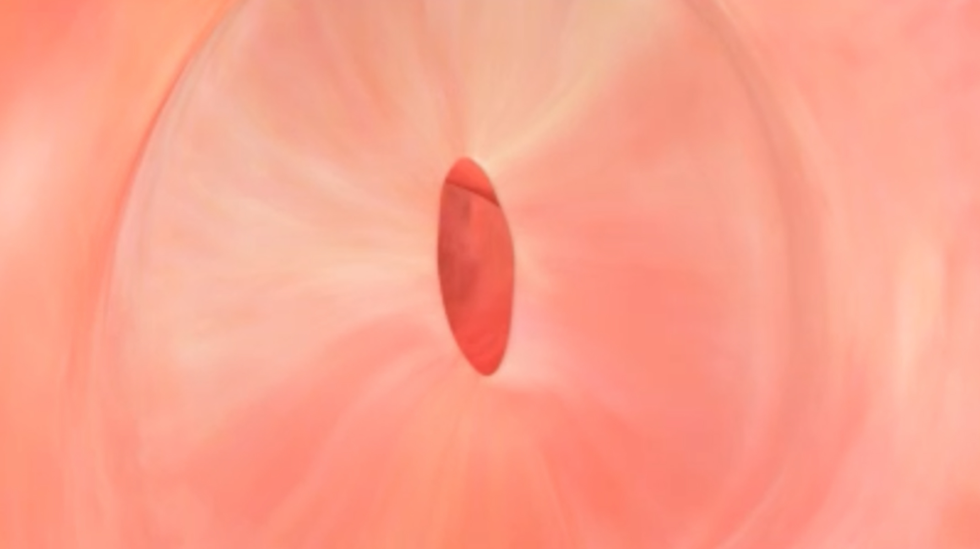

Image of gastrojejunostomy after many months in most patients with significant weight regain
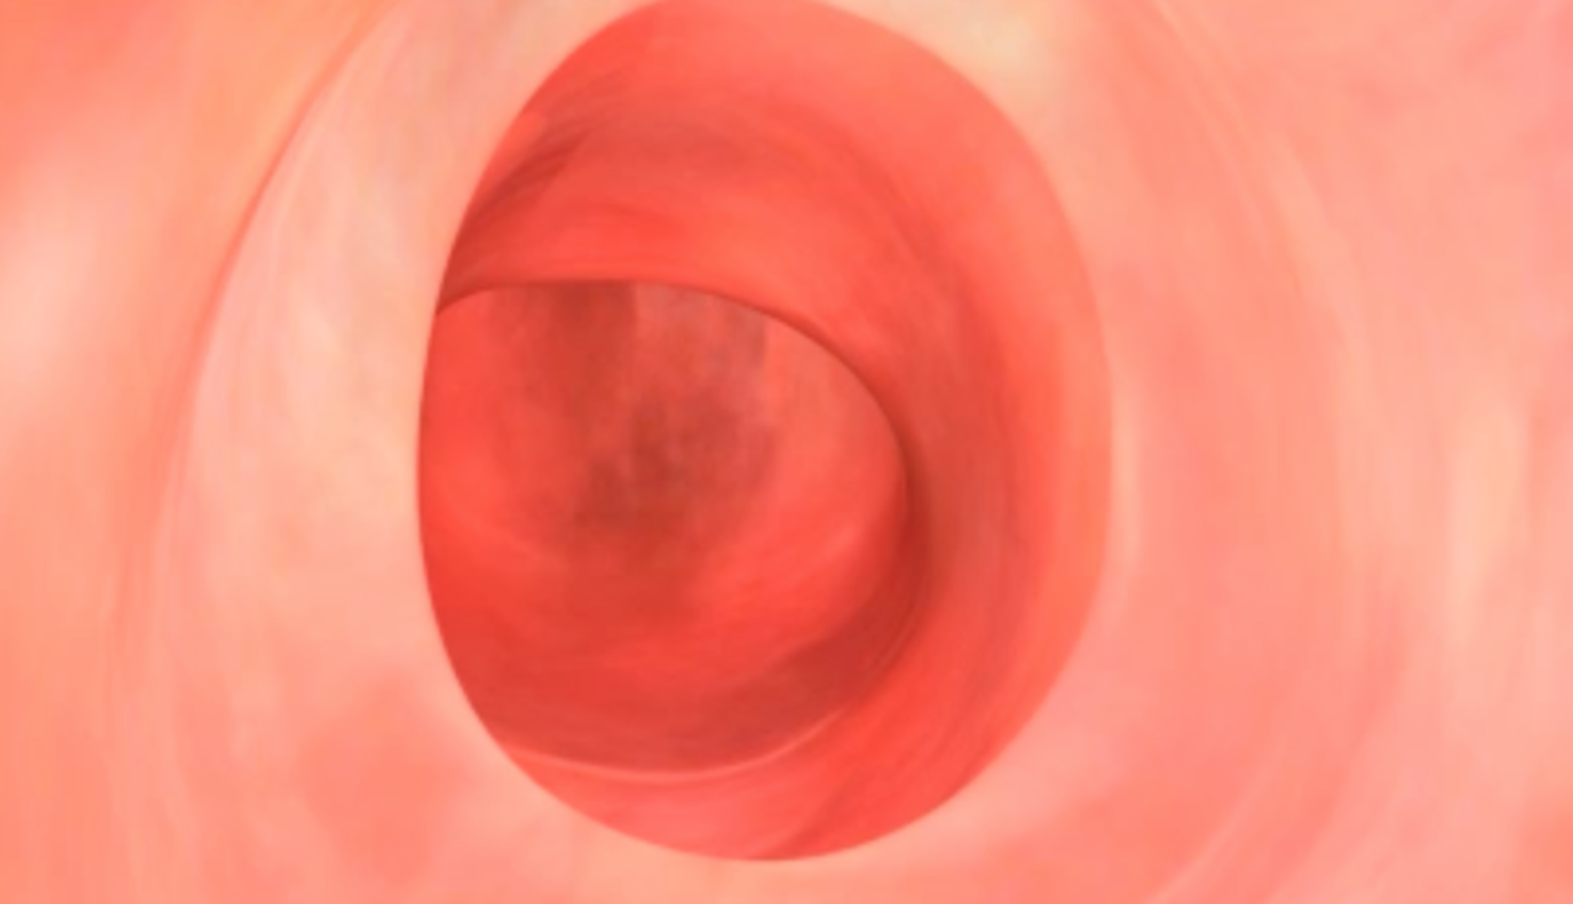

Image of gastrojejunostomy after Endoscopic Reduction of Stoma
